Assignment 2A: GitHub and Version Control

Name: Atharva Agrawal
RollNo: 33303
Batch: K-11

1) Git Init

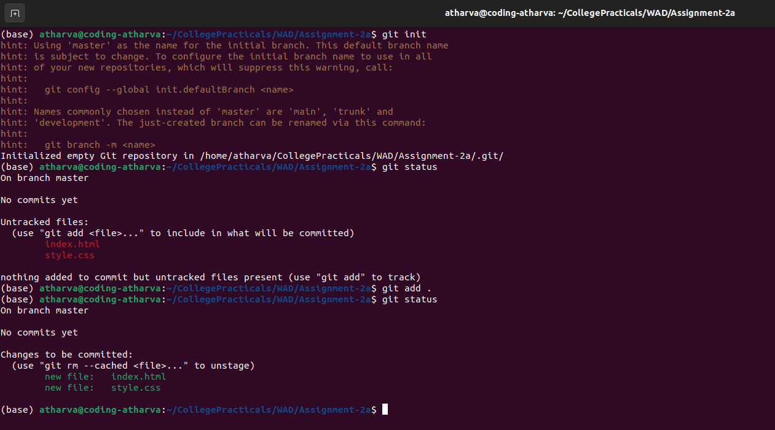

2) Git Commit

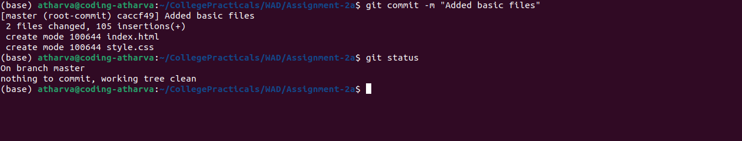

3) Git Remote Add Origin
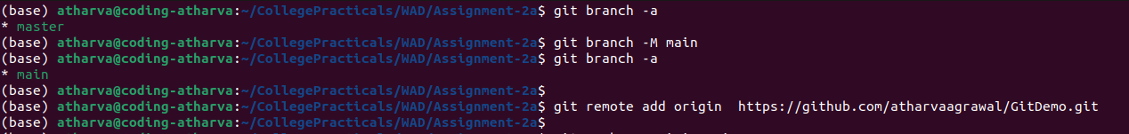

4) Pushing the Branch

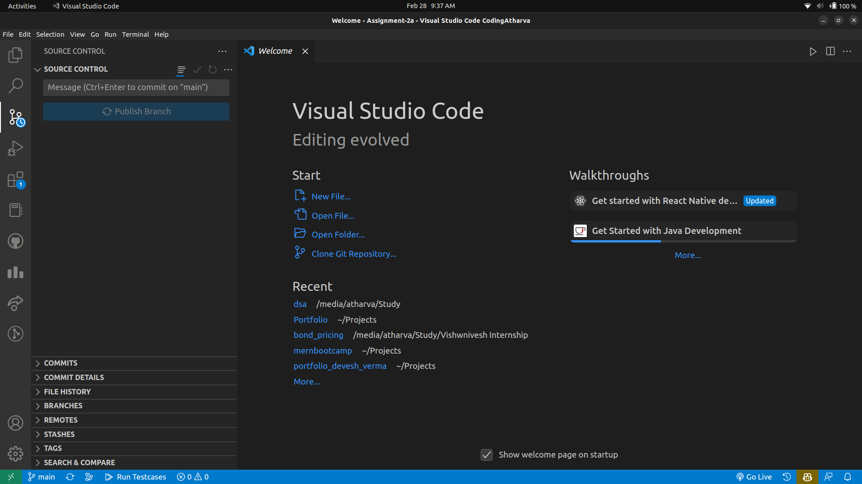

5) Before Commit

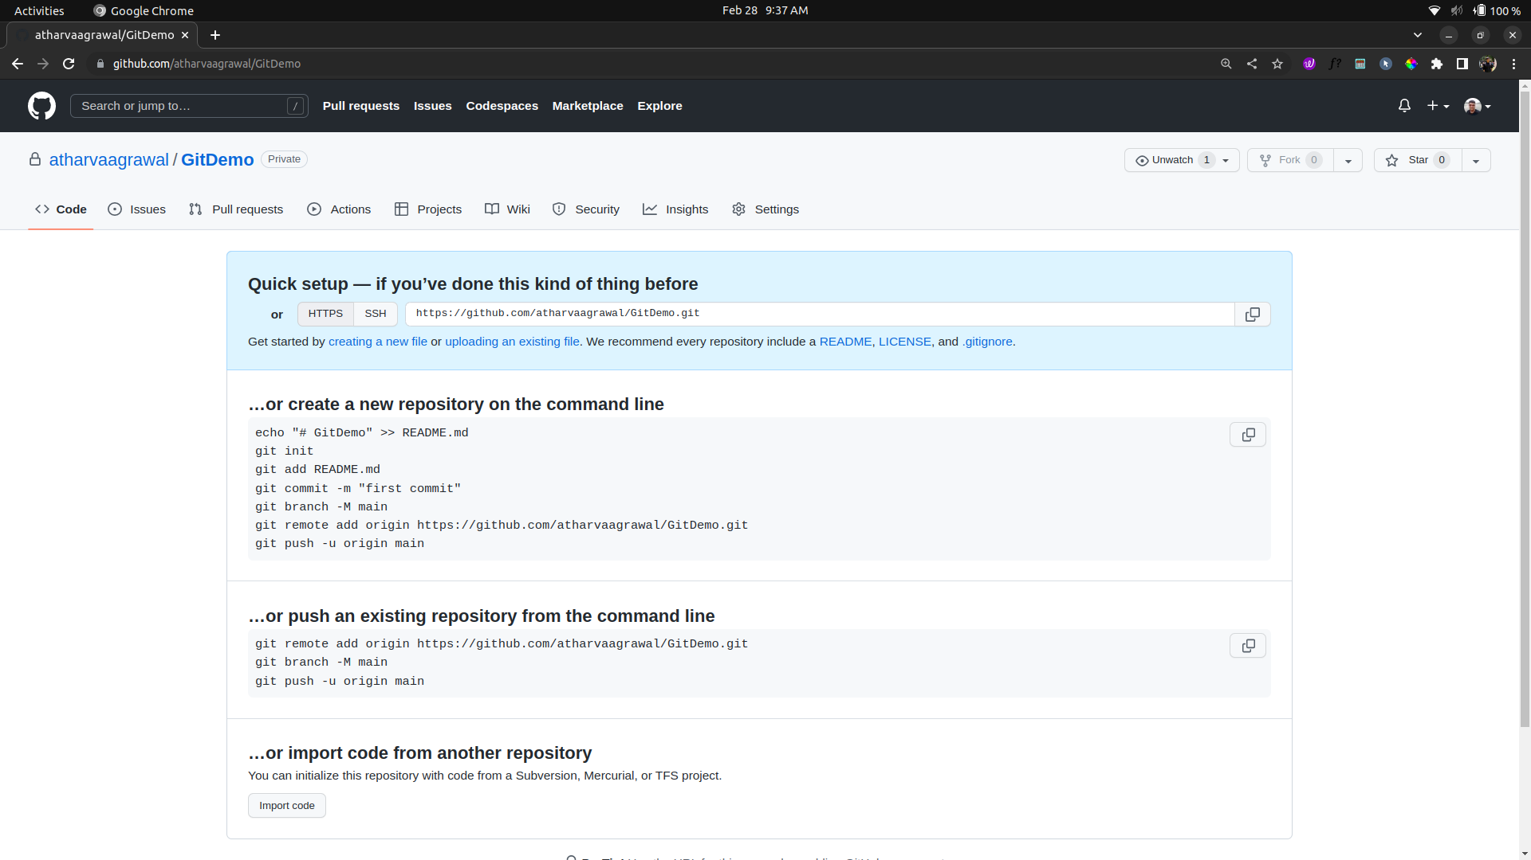

6) After Pushing

